**About us**

Aim:

To raise awareness about the inefficiency and plights that farmers face today.

Overview:

As students from D Y Patil International School Worli we bring to you our Global Perspective Group Project. We chose to raise awareness about the hard ships of farmers in an overall topic of agriculture and technology, we did this because being a part of India, a more of agriculturally based country. We see and hear about farmer suicide, farmer bills, less education, ineffective methods of farming and so many more such problems on a daily basis. We think that by raising awareness and possible drafting a potential solution it would help people gage a better understanding about their difficulties as farmers and support and help them out!

Ambition:

By the end of this project we hope to collect enough money to equip at least 20 farmers with new technologically advanced equipment, be able to successfully raise awareness and lastly come up with a potential solution to farmers problems and bring them to light. We will be posting various blogs regarding their problems, each in different aspects, we will also collaborate with experts in the field and post it out here and we hope it is convincing enough for you to help us improve their lives!

Aspiration:

This website is open to all ages, and we urge you’ll to help us give back to the farmers by donating as much as even Rs. 100. Lastly, we hope to make a change in farmers lives or maybe at least help contribute to their welfare, because in the end every life matters!

Founders:

Pratham Dave

Formal Pic

Sana Mehta

Formal pic

Shloak Rathod

Formal Pic

Varun Shah

Formal Pic

<https://www.google.com/url?sa=i&url=https%3A%2F%2Fwww.forbes.com%2Fsites%2Fforbestechcouncil%2F2018%2F09%2F20%2Fhow-agro-tech-is-helping-farmers-around-the-world%2F&psig=AOvVaw0CyypBfOez-e5fIlRQ4_Si&ust=1603952519399000&source=images&cd=vfe&ved=0CA0QjhxqFwoTCPiprKTV1uwCFQAAAAAdAAAAABAL>

<https://www.google.com/url?sa=i&url=https%3A%2F%2Fthewotrblog.wordpress.com%2F2020%2F06%2F29%2Fhow-wotr-is-helping-farmers-prepare-for-kharif%2F&psig=AOvVaw0CyypBfOez-e5fIlRQ4_Si&ust=1603952519399000&source=images&cd=vfe&ved=0CA0QjhxqFwoTCPiprKTV1uwCFQAAAAAdAAAAABAr>

<https://www.google.com/url?sa=i&url=https%3A%2F%2Fwww.thehindubusinessline.com%2Feconomy%2Fagri-business%2Fhelping-farmers-turn-into-millionaires-the-tata-trusts-way%2Farticle24857214.ece&psig=AOvVaw0CyypBfOez-e5fIlRQ4_Si&ust=1603952519399000&source=images&cd=vfe&ved=0CA0QjhxqFwoTCPiprKTV1uwCFQAAAAAdAAAAABAj>

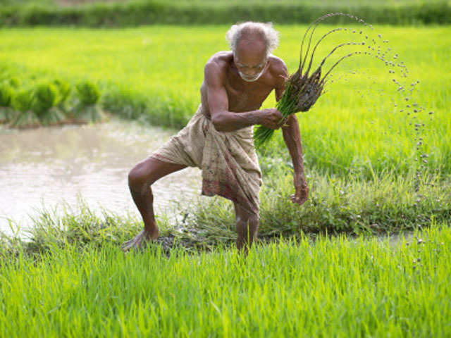

<https://www.google.com/url?sa=i&url=https%3A%2F%2Fm.economictimes.com%2Fnews%2Feconomy%2Fagriculture%2Fearly-monsoon-helping-farmers-plant-kharif-crops%2Farticleshow%2F53019333.cms&psig=AOvVaw0CyypBfOez-e5fIlRQ4_Si&ust=1603952519399000&source=images&cd=vfe&ved=0CA0QjhxqFwoTCPiprKTV1uwCFQAAAAAdAAAAABAa>